|  |
| --- |
| PROPOSAL for website development  Prepared by: Maryna Haidashevska,  Owner Web Time Company |
| Web Time Company 123 Main Street  Winnipeg, MB  R3M 2K7  Phone (204) 345-67-89  Email webtime@gmail.com |





****Dear Steve George,

Coffee Time is a modern company, with individual approaches for each of our clients. Our experienced, fully accredited team of professionals helps our clients to rebuild their current website or to create an innovative and creative new one according to your requirements for a decent price. We also have specialists in Web Design, Photoshop, which help to choose modern designs, fonts, effects according to each clients’ requirements. Thank you for your consideration with Web Time, and I look forward to discussing further steps with you in the near future.

Thank you,

V.Haidashevskyi

Vadim Haidashevskyi

Web Time

(204)123-45-67

**Proposal**

**From:** Maryna Haidashevska,

Web developer, Web Time Company

[haidashevska-m@webmail.uwinnipeg.ca](mailto:haidashevska-m@webmail.uwinnipeg.ca)

**To:** Steve George, Director Communications,

Coffee Time

<edu@pagerange.com>

**Date:** December 11, 2018

# 1.0 Background

Coffee Time is a small coffee shop which started running in January 2016. This is family business where Vadim and his wife treated each customer as a family member. They are planning to increase their online presence. They find that their current site doesn’t satisfied their customers’ needs, and not mobile friendly. Also, the company would like to change it, to make it well-organized, streamlined and structured, to do navigation easy for users, to do it mobile friendly Likewise, it’s important for company to make information about address more visible (for their primary audience – students and people who work in that area). Also, they would like to add a capability to add items in a shopping bag (for their second audience – people who would like to order a coffee in packages in lbs). For this scenario we need to convert your static website into dynamic website, to help our customers to interact with our website, to add items to the cart, to delete them, to make a payment, to make request for registration and login to their profile page, where they will see all information (which stored in server), also you’ll get full control of your website, its domain name, and all its contents. You can make any changes you want, and there is no limit on how much your site can grow in popularity, traffic, sales, and users.

# 2.0 Target Audience

## 2.1 Primary Audience

Coffee Time is located in a busy Downtown area close to one of the campuses of University of Winnipeg (Post-Secondary Education), to the head office of Manitoba Hydro, and to a big number of other organizations offices. It makes us assume that students (age 21 to 40 years) and adults with good jobs in Downtown offices (age 25-50) are our primary audience. Students before classes and during their breaks, and workers as well before their work or during the lunch time need to go somewhere to get a high-quality coffee and backing goods for affordable prices. Also, it is a good place to relax with friends after hard day or difficult exam. Owners are so passionate about their business, they try to make an atmosphere in their café very comfortable and friendly to every customer. So, our design will include simple message to attract attention for coffee shop location, show images as an best example what they can get and mention that prices are not so high as competitors’.

## 2.2 Secondary Audience

Coffee Time wants to start working in online sales. They want to sell coffee in packages for those who prefer to enjoy roasted coffee at home. So, our secondary audience would be older adults (ages 35-65 years) which have houses, big kitchens, and coffee-makers. Coffee Time plan to deliver orders more than 50$ for free. So, we plan to do our website IE compatible as we know older adults still prefer to work with older versions of IE. And make big touchable bottoms on our mobile version.

# 3.0 Goals and objectives

Coffee Time emphasized their expectations from a new website:

* Website matches to modern standards
* It will help to increase numbers of their new directory – online sales coffee packaging
* The new design is held to imply new company’s logo and updated pictures
* The site must allow their customers to order a coffee packaging
* Website could have an option allows to leave a feedback
* Must be functional, usable and easy-navigated

# 4.0 Project requirements and deliverables

* Streamline content
* User and mobile friendly (buttons bigger for older adults)
* Ability for customers to leave a feedback
* Design assume modern effects and fonts
* Usability testing
* Validate to W3C standards, CSS, HTML
* Needs to be compatible with older browsers (Internet Explorer 8)

# 5.0 Solutions and assumptions

We plan to keep all the content, but to reorganize and reupdate it, to do it mobile friendly. We plan to optimize content, to make windows to open faster, to do address information more visible as Call for Action (the most important one for our primary audience), to add an opportunity to leave a feedback for us as an additional information. We are assuming our client will provide with filling the content and choosing the appropriate photos and videos. We assuming to choose an appropriate hosting and programming according to your budget.

# 6.0 About us

We are modern company, with individual approaches for each of our clients. Our experienced, fully accredited team of professionals helps our clients to rebuild their current website or to create an innovative and creative new one according to your requirements for a decent price. We also have specialists in Web Design, Photoshop, which help to choose modern designs, fonts, effects according to each clients’ requirements.

The hourly rate for our services is $60

# 7.0 Budget

The following table shows the budget for each of phase of creating website

|  |  |
| --- | --- |
| ***Budget*** | ***Amount $*** |
| Planning | 900 |
| Design/Content | 1,500 |
| Coding | 1,000 |
| Programming | 2,000 |
| Launching/Maintenance | 1,500 |
| Miscellaneous | 600,00 |
| **Total cost** | **7,500** |

As it shown in the table above, the budget for this project will be $7,500

# 8.0 Work Plan

We are going to work on the following stages:

1. Planning.

This phase will begin on January 8, 2019. We plan to ask an additional information to our client, to ask them to be more specific about their needs and goals.

Planning tables for storing data (Logical model)

Product

Customer

Order

1

M

1

M

Order/

Product

M

1

Customer Table Schema:

customer([customer_id], first_name, last_name, is_admin, age, street, city, postal_code, province, country, phone, email, created_at, updated_at)

Order Table Schema:

order_id([order_id], cost, sub_total, quantity, gst, pst, total, customer_id, created_at, updated_at)

Order/Product schema:

order_id([order_id, problem_id], product_name, price, quantity, subtotal, delivery_cost, total)

Product Table Schema:

product([product_id], product_name, long_description, short_description, availability, country_of_origin, weight, price, roast, grind).



*Deliverables:* proposal approved, content outline, sitemap, blocks comps, choosing pictures, created tables in database

*Cost: $900*

1. Design.

To create an appropriate design, with required colours, fonts, with original pictures *Deliverable:* photoshop docs, original photography, final content

*Cost: $1.500*

Our team will design % HTML pages. The “Home” page will include the images of the coffee shop, information about location, with link to google map, and call to action. The “About” page will include the background of the company, their team, and equipment. The “Menu” page will include all company menu with descriptions. The “Shop” page will include the information and descriptions about all variety of coffee beans they offer, country of where they’ve been imported, and information about delivery. The “LogIn” page allows customers to enter to their profile. The “Register page” allows new customers to register on their web site. They have to provide all information required in registration form. Our created validators will check if the information provided is safe and meet requirements for each field. Customers have to create their own passwords (that meet out criteria). We plan to store our information using cryptographic hash functions, which prevent our stored passwords from using

* Dictionary Attacks
* Bruteforce
* Rainbow Tables

Then customer would be able to log In into their profile and to check all their information. After login customer would be able to see a profile page with all information provided before. The “Contact” page will include the information about location, hours of operation.

Home

About

Menu

Shop

LogIn

Register

Profile

LogOut

Cart page

Payment methods

Thank you page

Cart

List View

Detailss

Search

Dashboard for backend:

But when you accessing as an Admin, you will have more option when accessing into your profile, and would be able to search for records, to select record to edit, delete records and add.

Dashboard

LogIn/LogOut

Products

Add

Delete

Update

Customers

Add

Delete

Update

Orders

Add

Delete

Update

****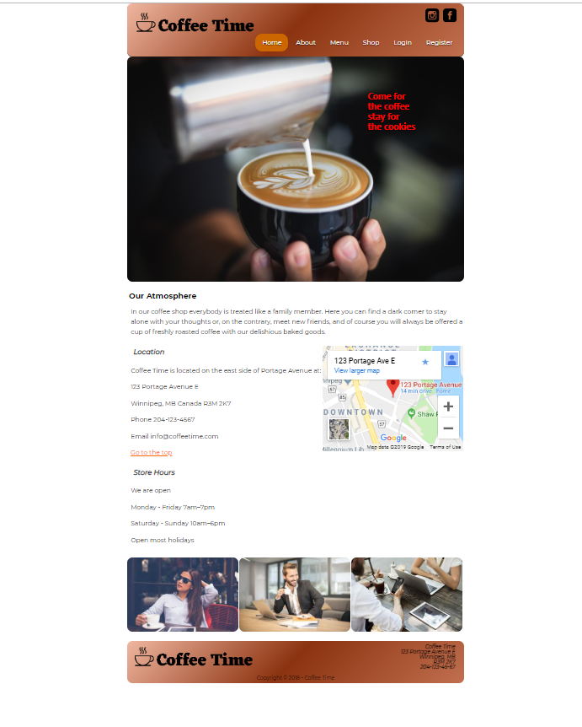

****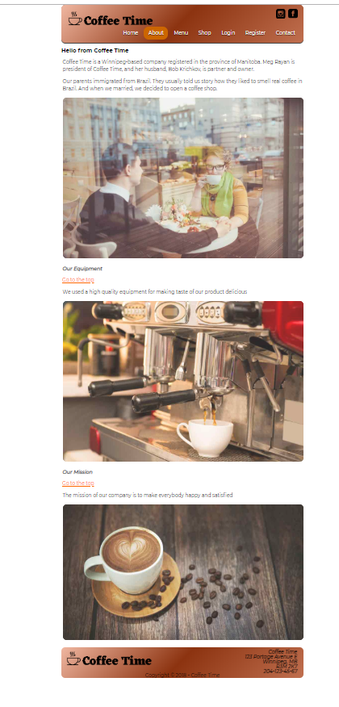

****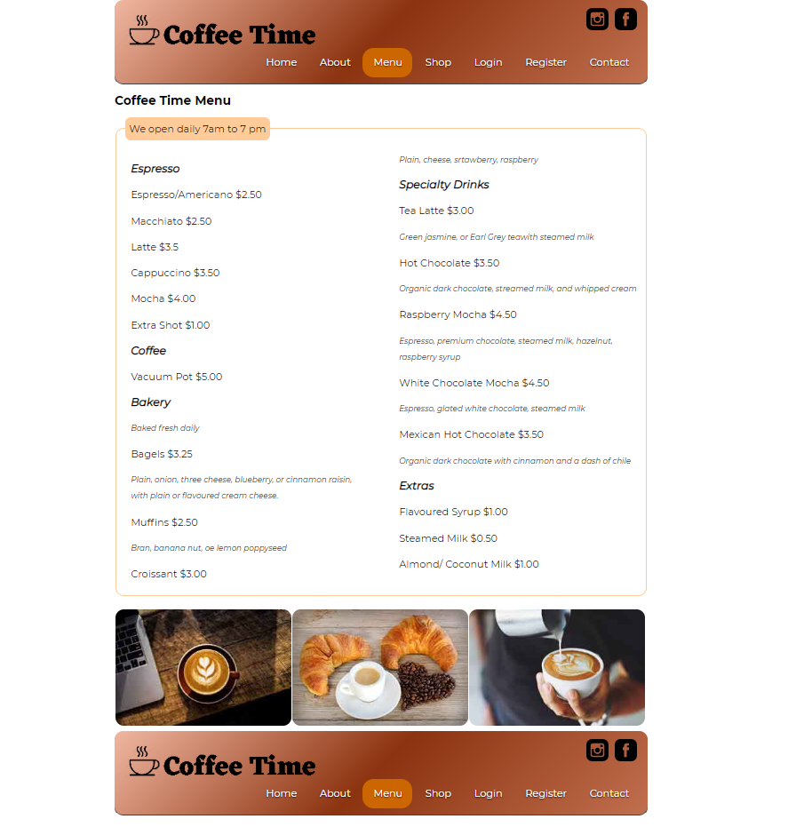

 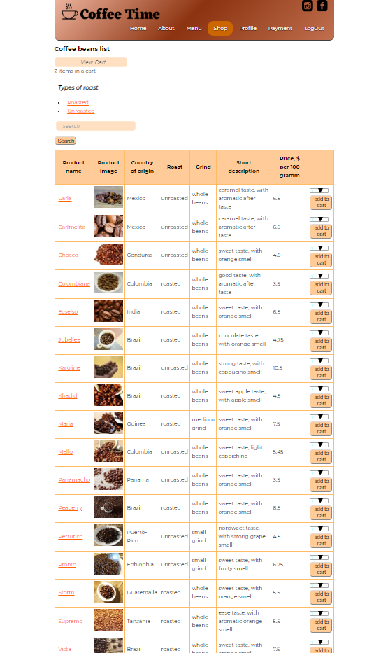



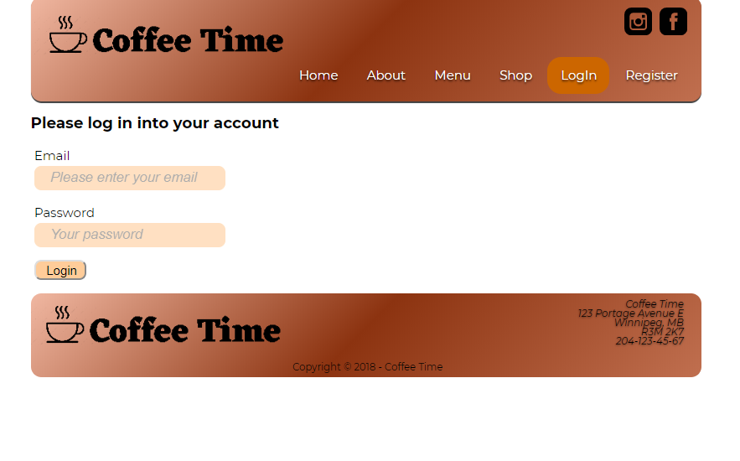

****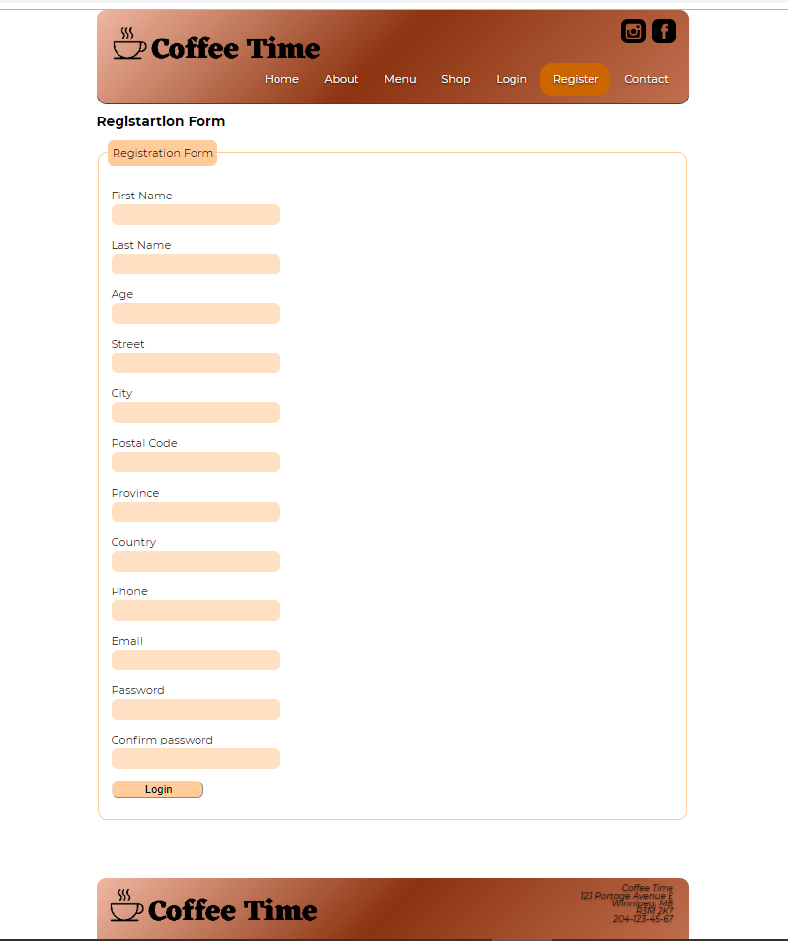

 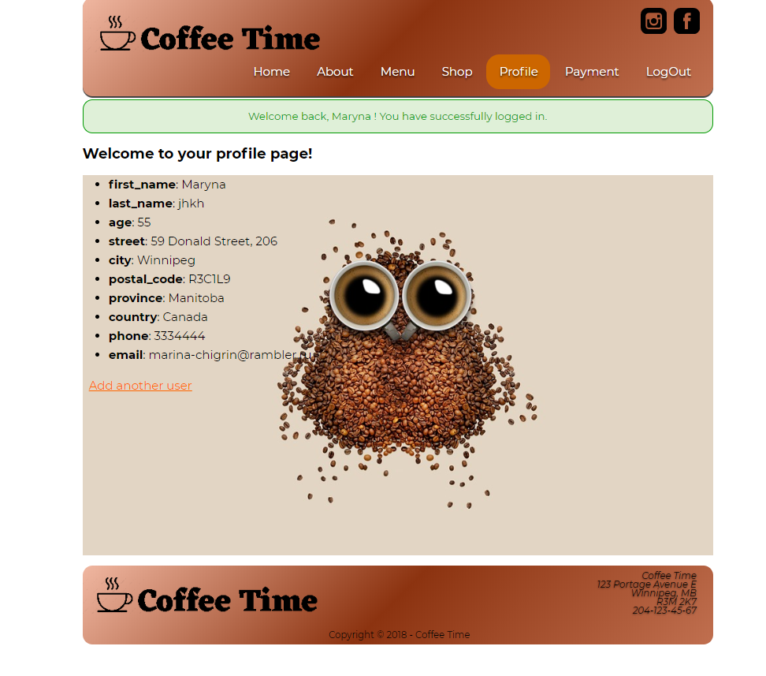



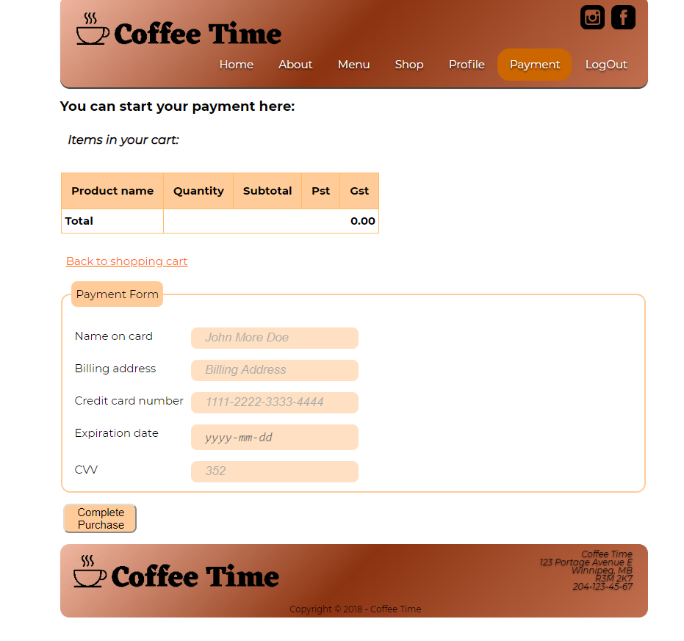

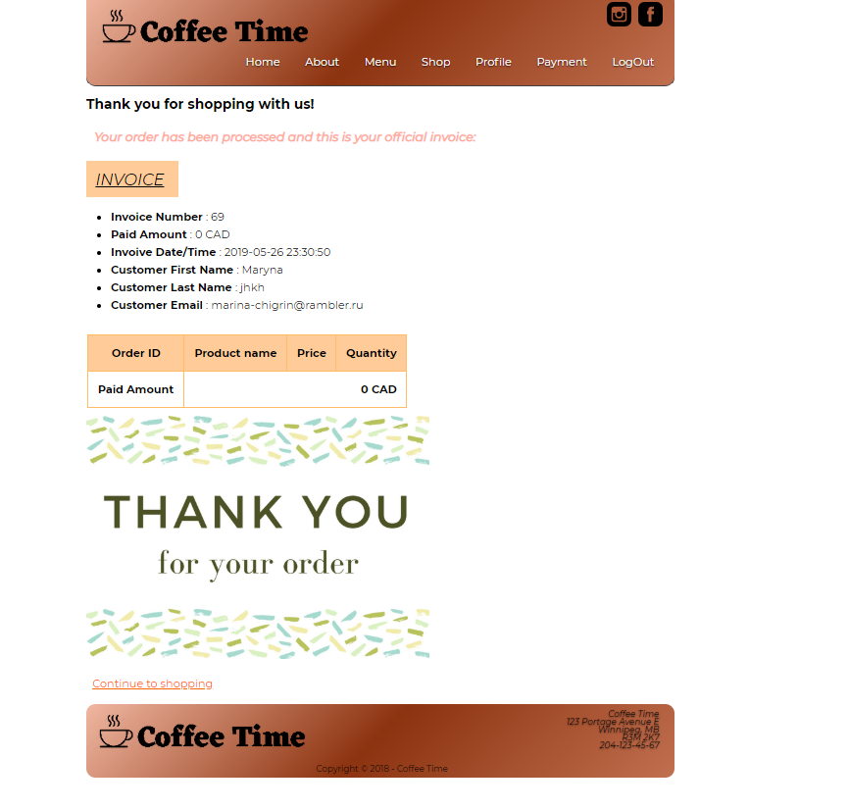

ADMIN PAGES:

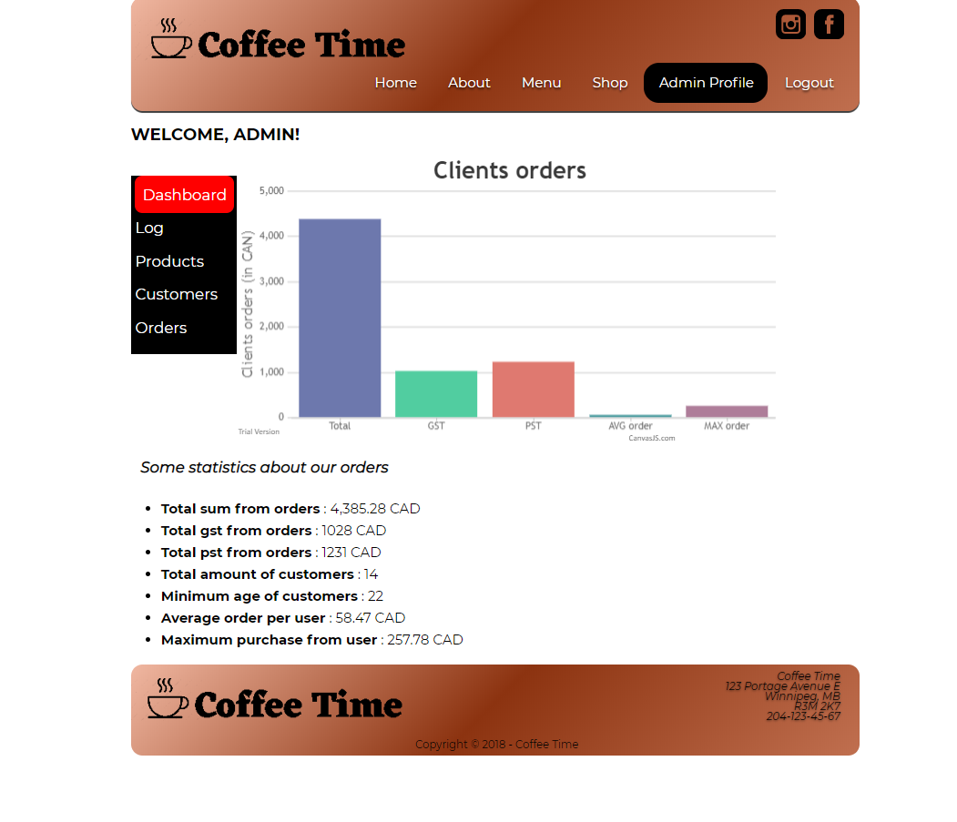

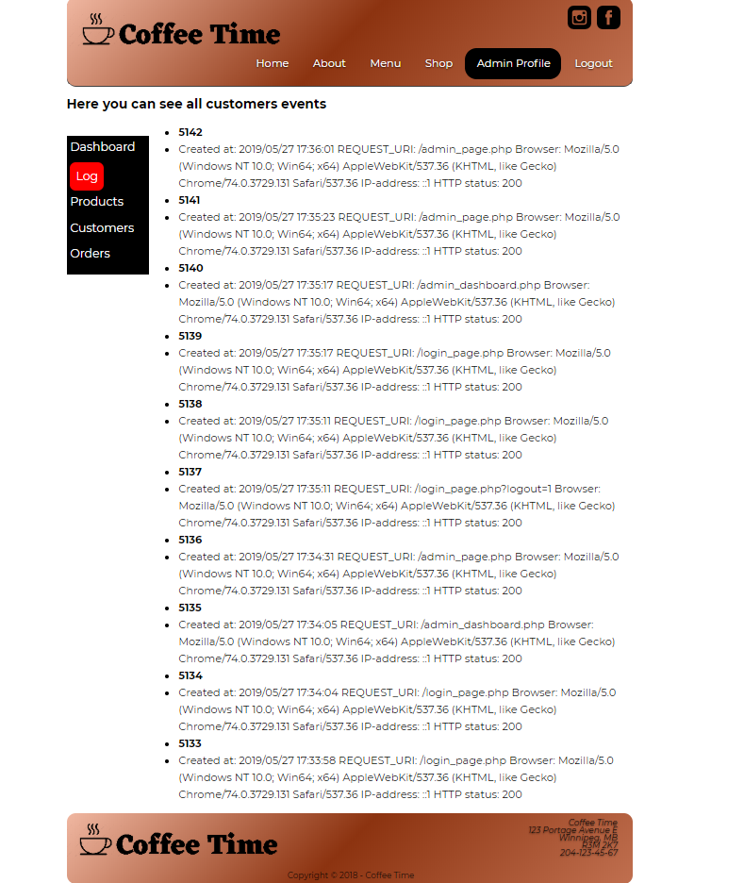

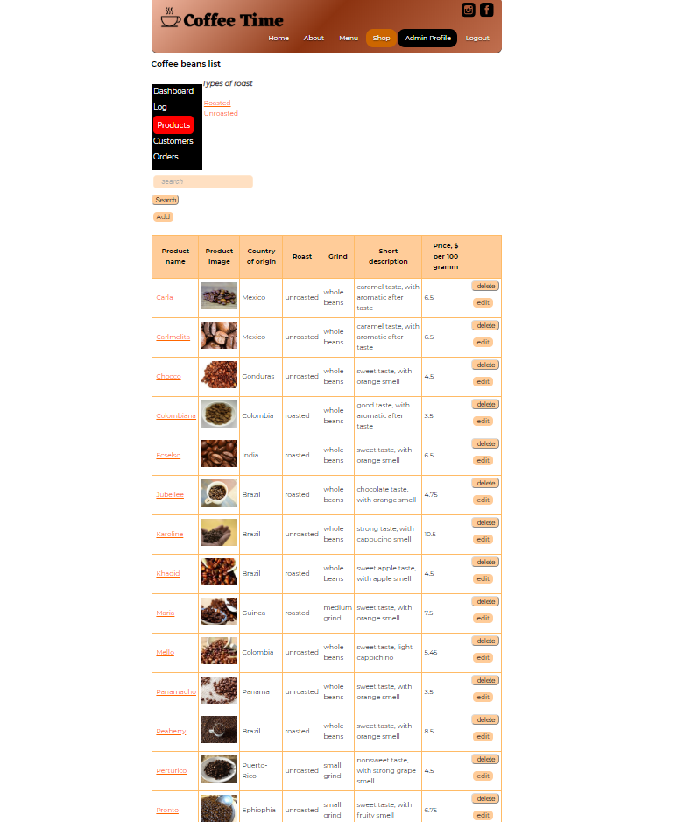

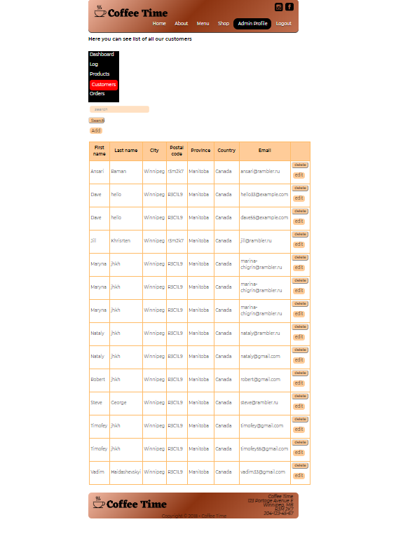

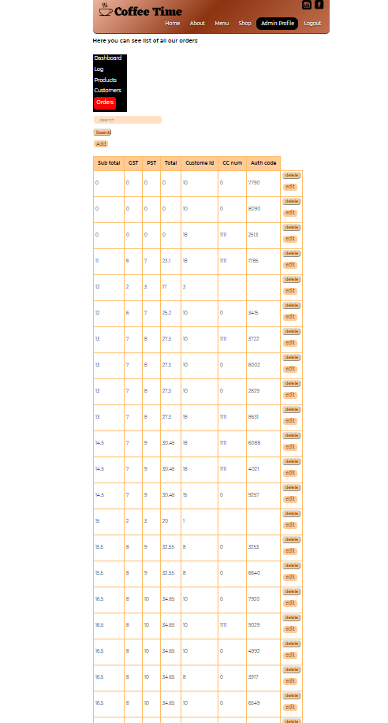

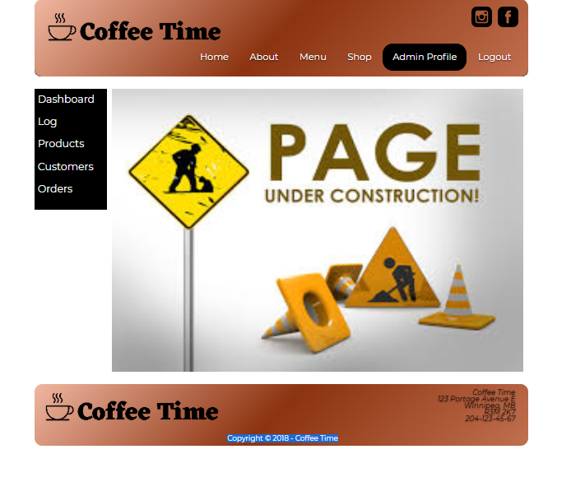

1. Coding: on this phase we are choosing language of coding, coding, front end, slicing PSDs, planning approach, testing.

*Deliverable:* code HTML, review PSDs, clients’ approval

*Cost: $3,000*

1. Launching: we continue testing, working with mistakes (if found) define approach, normalizing, define framework. *Deliverables:* ready to launch website

*Cost: $1,500*



# 9.0 Conclusion

We are looking forward to hearing from you. It’s a great pleasure for us to have an opportunity to work with your organization.

 Appendix 1

**Workback Schedule**

**From:** Maryna Haidashevska,

Web developer, Web Time Company

[haidashevska-m@webmail.uwinnipeg.ca](mailto:haidashevska-m@webmail.uwinnipeg.ca)

**To:** Steve George, Director Communications,

Coffee Time

<edu@SteveGeorge.com>

**Date:** December 07, 2018

|  |  |  |
| --- | --- | --- |
| **Task** | **Responsible** | **Date** |
| Work Starts | WEB TIME | Jan 3 |
| Planning phase begin | WEB TIME | Jan 3 |
| Schedule meeting with client | WEB TIME | Jan 3 |
| Creative brief complete | WEB TIME | Jan 3 |
| Creative Brief approved | COFFEE TIME | Jan 4 |
| Content outline completed | WEB TIME | Jan 5 |
| Content outline approved | COFFEE TIME | Jan 6 |
| Planning Phase Brief | WEB TIME | Jan 10 |
| Design/ content phase begins | WEB TIME | Jan 15 |
| Beginning designing based on Creative Brief | WEB TIME | Jan 15 |
| Original photography | COFFEE TIME | Jan 20 |
| Organized PSDs | WEB TIME | Jan 24 |
| Sending to client for review | COFFEE TIME | Jan 29 |
| All content approved | COFFEE TIME | Jan 31 |
| Design approved | COFFEE TIME | Feb 1 |
| Content for designers for placement | WEB TIME | Feb 1 |
| Design/content phase ends | WEB TIME | Feb 1 |
| Coding/Programing phase starts | WEB TIME | Feb 1 |
| Review PSDs and plan approach | WEB TIME | Feb 5 |
| Slicing PSDs | WEB TIME | Feb 10 |
| Code SSS,Validate SSS | WEB TIME | Feb 13 |
| Coding HTML completed/approved | WEB TIME | Feb 13 |
| Client review | COFFEE TIME | Feb 13 |
| Testing | WEB TIME | Feb 15 |
| Client approved | COFFEE TIME | Feb 19 |
| Launching phase starts | WEB TIME | Feb 19 |
| Report to a client | WEB TIME | Feb 25 |
| Manage errors | WEB TIME | Feb 28 |
| Site Launched | WEB TIME | Mar 04 |

**Timelines**

|  |  |  |  |
| --- | --- | --- | --- |
| Task | Responsible | Hours | Cost ($) |
| Planning phase begin, meeting with client, brief complete | Maryna Haidashevska | 10 | 600 |
| Content outline completed | Maryna Haidashevska, Vadim Haidashevskyi | 5 | 300 |
| Beginning designing based on Creative Brief | Maryna Haidashevska | 5 | 300 |
| Original photography | Vadim Haidashevskyi | 5 | 300 |
| Organized PSDs | Maryna Haidashevska | 8 | 480 |
| Sending to client for review | Vadim Haidashevskyi | 1 | 60 |
| Content for designers for placement | Vadim Haidashevskyi | 9 | 540 |
| Design/content phase ends | Maryna Haidashevska | 2 | 180 |
| Coding/Programing phase starts | Vadim Haidashevskyi | 35 | 2100 |
| Review PSDs and plan approach | Maryna Haidashevska | 7 | 420 |
| Slicing PSDs | Vadim Haidashevskyi | 8 | 900 |
| Testing | Vadim Haidashevskyi | 5 | 300 |
| Report to a client | Maryna Haidashevska | 8 | 480 |
| Manage errors | Vadim Haidashevskyi | 8 | 480 |
| Site Launched | Maryna Haidashevska | 4 | 240 |

Plus miscellaneous $600

Total cost: $7.500

|  |  |
| --- | --- |
|  | Invoice |
| Web Time Company | INVOICE # No.1  Date: December 10, 2018 |
| 123 Main Street, Winnipeg, MB, R3M 2K7  Phone Phone (204)345-67-89  Email [coffeetime@gmail.com](mailto:coffeetime@gmail.com) | Date |



|  |  |  |  |
| --- | --- | --- | --- |
|  |  | Steve George  Coffee Time Company  123 Portage Avenue,  Winnipeg, MB, R3M 2K7  (204)345-67-89 |  |

|  |  |  |  |
| --- | --- | --- | --- |
| description | Hours | unit price | line total |
| Planning | 15 |  | 900,00 |
| Design/Content | 25 |  | 1,500 |
| Coding | 20 |  | 1,000 |
| Programming | 30 |  | 2, 000 |
| Launching/Maintenance | 25 |  | 1,500 |
| Miscellaneous |  |  | 600,00 |
|  |  |  |  |
|  |  |  |  |
|  |  |  |  |
|  |  |  |  |
|  |  |  |  |
|  |  |  |  |
|  | | Subtotal | 7,500 |
|  | | Sales Tax | 0 |
|  | | Total | 7,500 |

|  |
| --- |
| Quotation prepared by:  This is a quotation on the goods named, subject to the conditions noted below: Describe any conditions pertaining to these prices and any additional terms of the agreement. You may want to include contingencies that will affect the quotation.  To accept this quotation, sign here and return: |
| Thank you for your business! |